**DTUHUB**

**STUDENT TO STUDENT**

**MARKETPLACE**

A Major Project submitted

For the partial fulfillment of the degree of

Bachelor of Engineering in

Computer Engineering

(Session 2014-2015)



Submitted by:

Ramdev Sehrawat(2K11/CO/90)

Ravi (2K11/CO/93)

Saurav singh(2k11/CO/101)

Vijay kumar kharwar(2K11/CO/124)

Department of Computer Engineering

Delhi Technological University

New Delhi

**ABSTRACT**

The goal of the website is not only limited to attracting and encouraging college students to take coursework at IITs, NITs, DTU, NSIT but it also aims to provide information about institute keeping in mind that the person visiting this website wants a full knowledge of the college syllabus and accommodations for outsider students and selling old books through advertisments. This website also contain the feedback box. The important feature of the website is filtertion. It filtered by college name.

Website is aimed toward students who are pursuing their studies or graduation and are looking for a college syllabus and question papers. Maintaining a teen friendly site is deemed of highest importance in order to hold student attention and guide the viewer to information that will lead to a decision to pursue a career in BE, M.TECH in the respective college.

**ACKNOWLEDGEMENT**

We take this opportunity to express our sincere gratitude to all those who helped us in various capacities in undertaking this project and devising the report.

We are privileged to express our sense of gratitude to our respected teacher Mr. RAM MURTI RAWAT whose unparalleled knowledge, moral fiber and judgment along with his know-how, was an immense support in completing the project.

We are also grateful to Mr O.P Verma, the Head of Computer Department, for the brainwave and encouragement given.

We take this opportunity also to thank our Seniors and contemporaries for their cooperation and compliance.

**TABLE OF CONTENTS**

1. Declaration …………………………………………………………………… 1

2. Introduction …………………………………………………………………… 2

3. System Requirement Specification ………………………………….. 3

4. Technology overview ………………………………………………………. 4

5. Project description ……………………………………………………….. 6

6. Snapshots ………………………………………………………………………. 11

7. Scope of project ………………………………………………………………. 17

8. Contribution in project ……………………………………………………. 18

9. Bibliography …………………………………………………………………….. 20

**DECLARATION**

**Delhi Technological University**

**DEPARTMENT OF COMPUTER ENGINEERING**

**CERTIFICATE**

**2014-15**

This is to certify that the project titled “DTUHUB” is a bonafied work carried out by following

Computer Engineering students:

1. Vijay Kumar Kharwar

2. Ramdev Sehrawat

3. Ravi Kumar

4. Saurabh Singh

Under our guidance towards the partial fulfillment of the Requirements for the degree of the Bachelor of Technology by DTU, Delhi during the academic year of 2014-2015

MENTOR OF DEPARTMENT

(Ram Murti Rawat)

**INTRODUCTION**

The purpose of the website is to provide a college student friendly set of web pages that are easy to navigate and at the same time provides sufficient depth and information about college syllabus and question paper respective their college.

Two potential groups of viewers exist:

1. Students interested in BE, M.TECH or MBA seeking more in-depth information about a College.
2. Students that are in that college but are seeking for some information for other colleges

syllabus.

The website will be authenticated and the site provides a safe environment for online users.

It may fall short of certain requirements and may require some additional functionality if it is to be used for General Audience.

**SYSTEM REQUIRMENT SPECIFICATION**

Name of the Project: DTUHUB STUDENT TO STUDENT MARKETPLACE

Objectives:

▪ Online registration of students

▪ Information about college Syllabus and related notes, books, previous year question papers etc.

▪ Forum for Students to interact with other college students and professors.

Users Views:

▪ Administrator

▪ Student

1. Students interested in BE, M.TECH or MBA seeking more in-depth information about a College.
2. Students that are in that college but are seeking for some information for other colleges

syllabus.

**Platform:**

Operating Systems: Microsoft Windows

Technologies Used:

▪ Front End: HTML and CSS

▪ Web designing language: PHP

▪ RDBMS(Back end): MySQL

▪ Ajax

▪ Javascript

**Software Requirements:**

▪ PHP 5.3.0

▪ APACHE HTTP Server

▪ Microsoft Windows

**Hardware Requirements:**

▪ Intel Pentium IV processor or equivalent or higher

▪ 512 MB Ram or Higher

▪ 20 GB HDD or Higher

▪ Network Connectivity

**TECHNOLOGY OVERVIEW**

Major features of the website include the following pages/subsections:

SELECT CATEGORY :

1. Books.
2. Student Resources.
3. Gadgets and Vehicles.
4. Housing and Furnitures.
5. Apparel and Accessories.
6. Other services.
7. Search Engine.

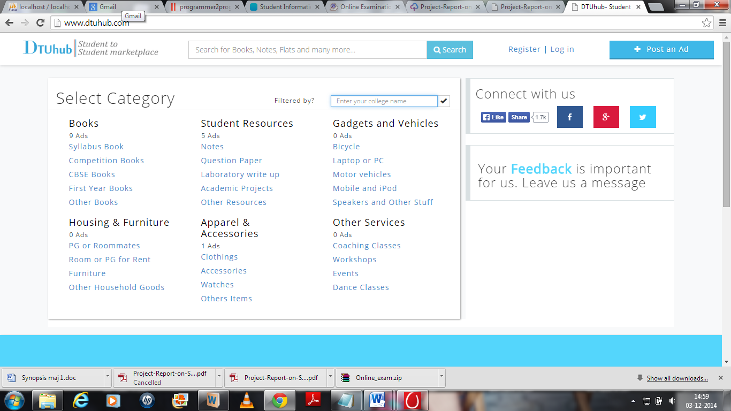

“Filtered by?” textfield is used to filter the ‘Select Category’ according to college Selected.

Similarly other features like considering the feedback of the customer for the improvement of the site and to add other important features. Customer/Student can connect to us through facebook, twitter, google+ for further updates of the site like new books, notes which are added.

For the Filtering purpose we have used ‘Booth Algorithm’ for improving our search and for making our search fast. We have also included the feature for selling second hand books. We are looking forward for including more colleges in the hub and make it easier for students to gather knowledge as much as possible.

**PROJECT DISCRIPTION**

1. **PROBLEM DOMAIN**

The basic problem faced by students is inconvenience of visiting college for each and every requirement viz syllabus, question papers and many things.

For such details a student is required to visit college in their vacations which is really time consuming and hectic for students living out of station as they have to travel so long for general formalities.

The website gives flexibility to students so that they can obtain the respective information right from their desk about syllabus and papers.

**2. SOLUTION DOMAIN**

The website is user friendly and it doesn’t requires any training or extra effort to understand it properly. It provides a number of facilities on a single click of mouse.

This system is aimed at the smooth functioning of the college filtered management procedure. In order to achieve this website contains following features:

* SELECT CATEGORY :

**Books. Student Resources**

Syllabus books Notes

Competition books Question papers

CBSE books Laboratory write up

First year books Academic projects

Other books Other resources

**Gadgets and Vehicles Housing and Furnitures**

Bicycle PG or Roommate

Laptop or PC Room or PG for Rent

Moter and vehicles Furnitures

Mobiles and iPods Other Household goods

**Other Services**

Coaching Classes

Workshops

Events

Dance Classes

**3. SYSTEM DOMAIN**

**Platform Specification:**

**Software Implementation Software:**

* Windows Operating System.
* Mozilla Firefox, Google Chrome, Opera, Internet Explorer
* XAMPP Server

**4. APPLICATION DOMAIN**

* This system is aimed at the smooth functioning of the College students materials.
* Maintaining a teen friendly site is deemed of highest priority in order to hold student attention and guide the viewer to retrieve information about the college.
* A user-friendly college site where any kind of information about the college is provided on a single click.
* Maintaining a feedback column will help website to frequently change according to user need.
* Website is aimed toward students who wish to selling or purchase books from other students.

**5. EXPECTED OUTCOMES**

The outcomes expected are as follows:

* Smooth and effective functioning of College management procedure.
* Any kind of information could be provided to the user.
* BE, MBA and M.TECH course and other information from college
* Timely and up to date information that encourages readers to return to the site.
* Call to action, and plans for students to follow to prepare for a BE, MBA and M.TECH career.
* The basic problem faced by students is inconvenience of visiting college for each and every requirement viz. fee structure, registration, announcements, bus route is solved.

**SNAPSHOTS**

**HOME PAGE:**

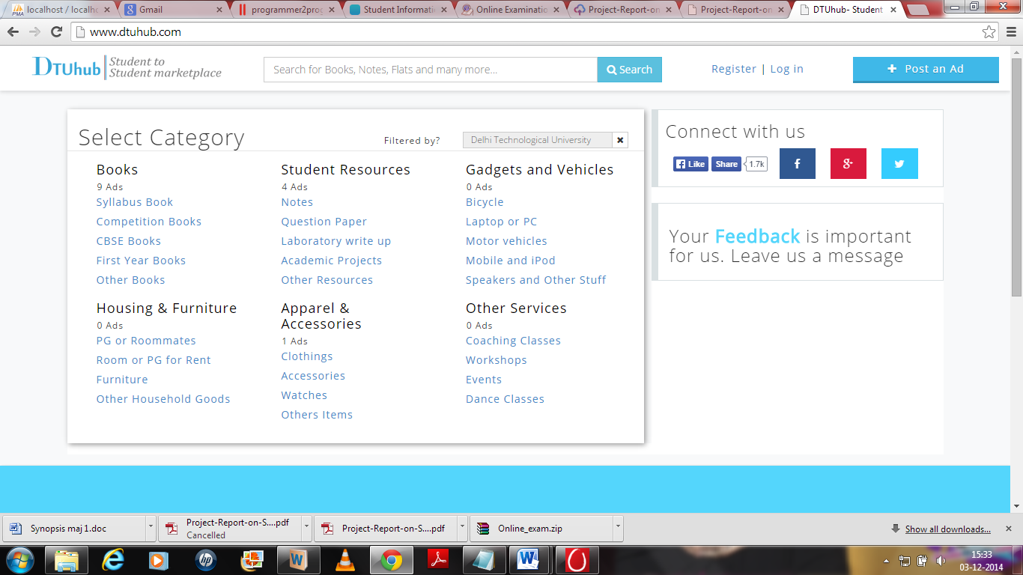

**SYLLABUS BOOK**

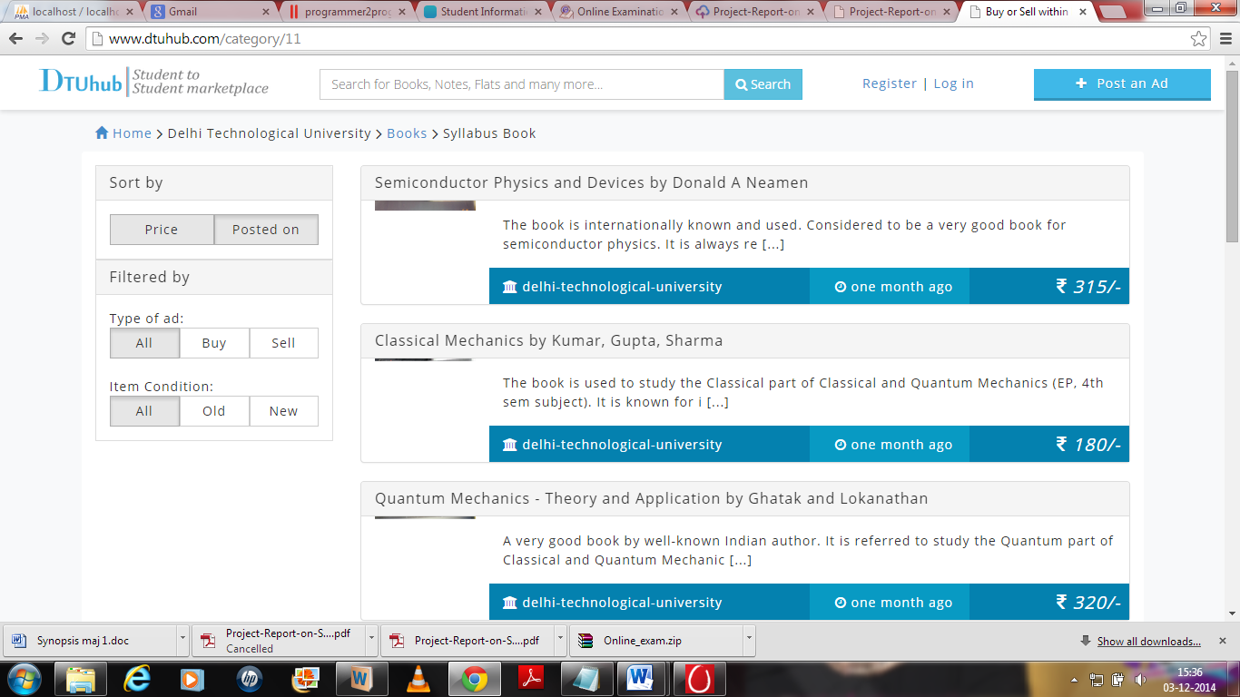

**QUESTION PAPERS**

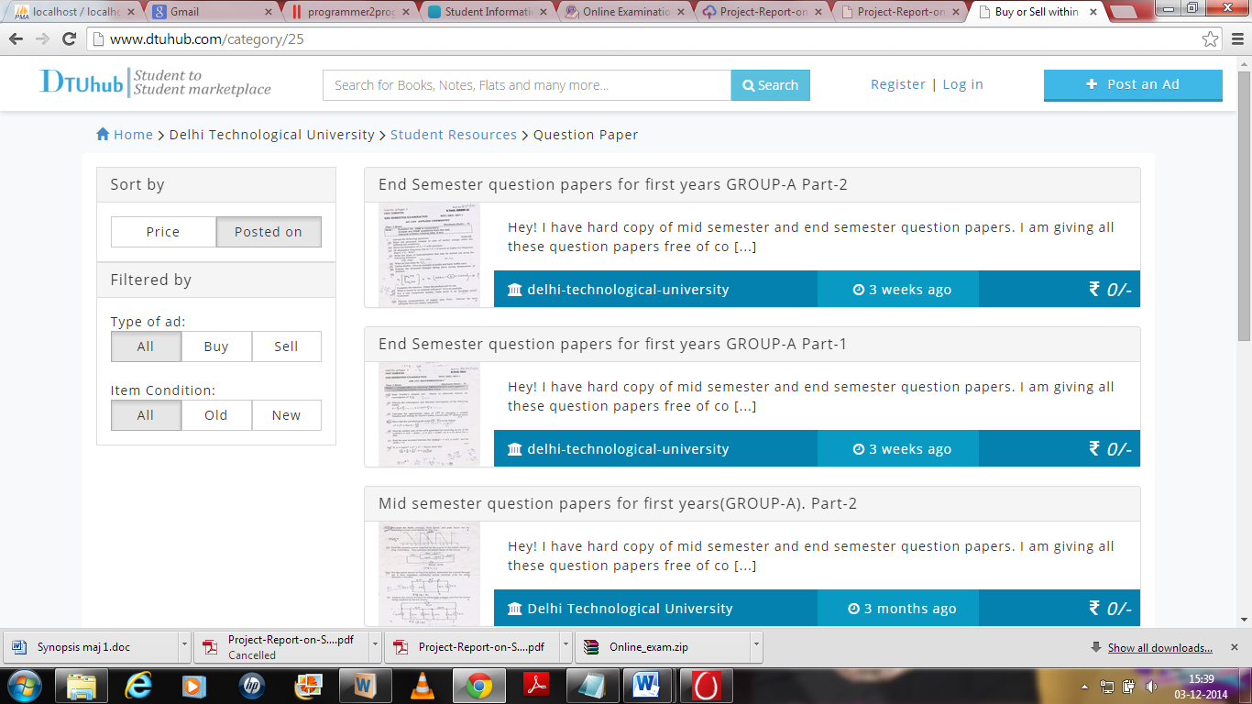

**SELLING BOOKS**

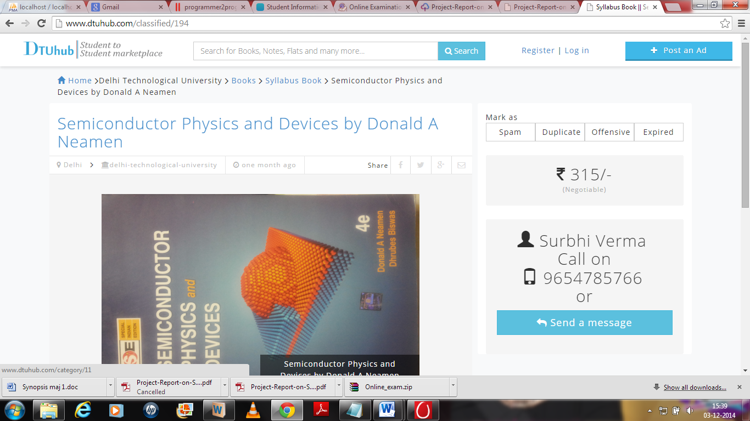

**LOGIN PAGE**

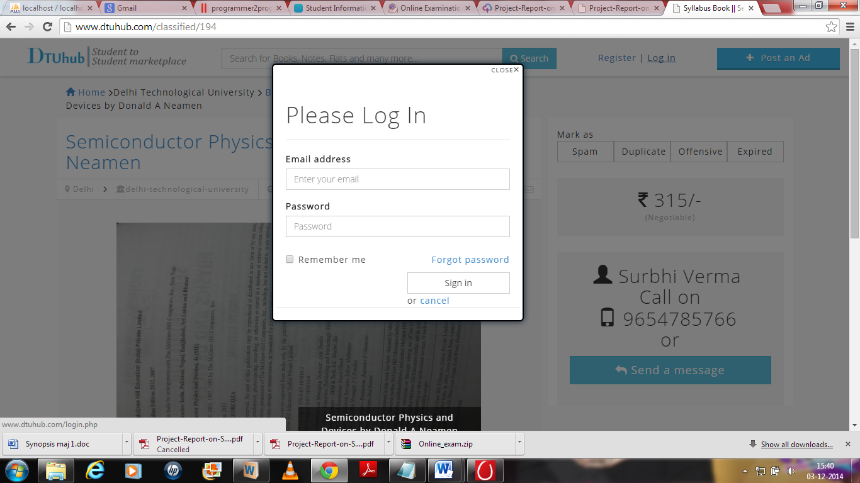

**POST NEW AD**

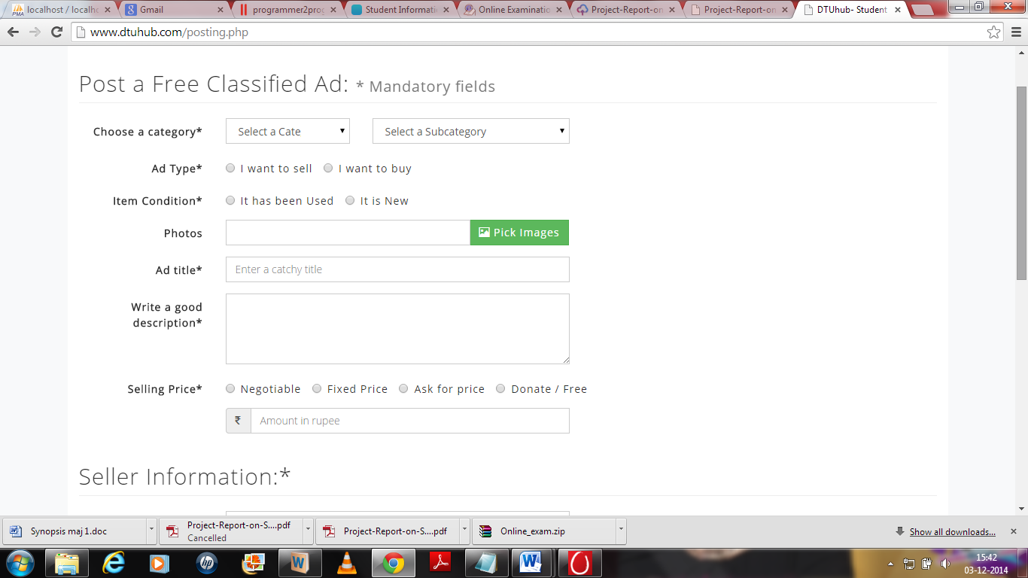

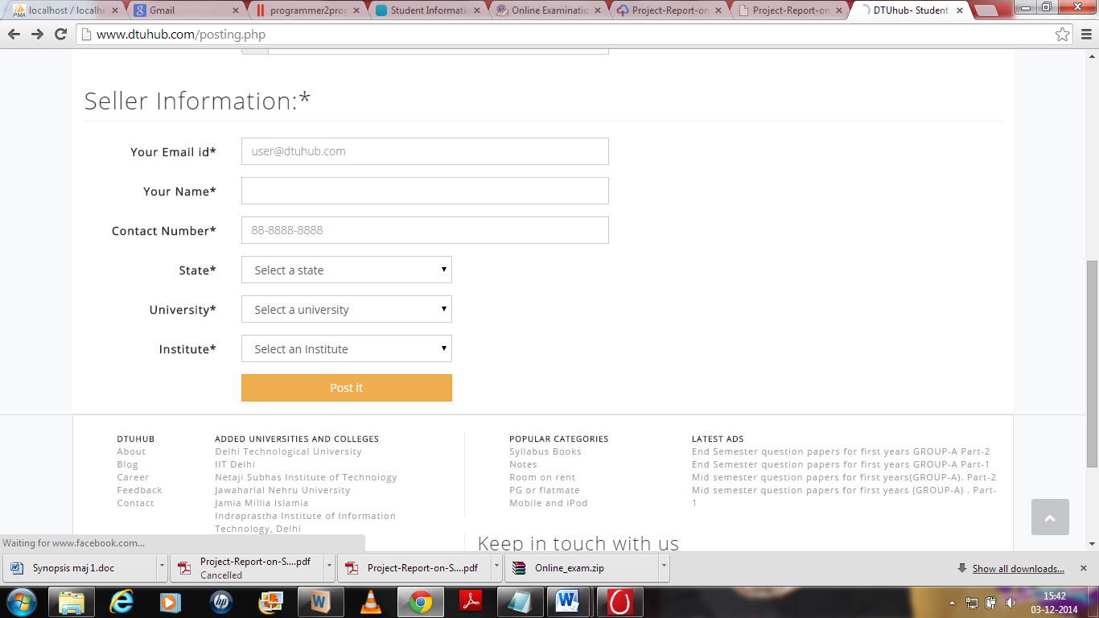

**7.Scope of project:**

It is the DTU HUB ,student to student market place, where the student can find

The academic related materials and place for accommodations.

This website also provide the facility for merchants where they can sell and

Advertise their products. For the future this website will be upgraded on the basis of geospace of colleges. which is automatically detect the location of

Nearest colleges and provide the information for those colleges.

It is the student to student market place website where every students of any college can interact with other students. Like if student of Delhi Technological

University want to sell their things on this website then student of Indian institute of technology can buy those thing by the help of this website.

**8.Bibliography:**

<http://forum.codecall.net/forum/158-php-tutorials/>

<http://php.net/urlhowto.php>

<http://www.w3schools.com/php/php_intro.asp>

<http://www.w3schools.com/js/js_function_closures.asp>

www.c4learn.com/c-programming/source-vs-object-code/ source code and object code

<https://github.com/codybutz/codehub/blob/master/views/forum/layout.jade>

<http://www.codeproject.com/Articles/654298/How-to-Run-Grid-based-Web-Applications-and-Databas>

**Source Code:-**

**PHP:**

<?php

$css_files = array('bootstrap.css','font-awesome.min.css','slippry.css','style.css');

/*

* Include necessary files

*/

include_once 'sys/core/init.inc.php';

$category = new ClassifiedCategory($dbo);

$rawData= $category->_loadPostData($id,'publish');

$page_description=$rawData[0]['post_content'];

/*

* Load the calendar for January

*/

include_once'assets/common/header.inc.php';

$results=$category->getPrice($id);

$seller= $category->getSellerInfo($results[0]["post_author"]);

/*

* Output the header HTML

*/

?>

<div class="container"> <div class="row">

<div class="col-md-8 background-background">

<?php

echo $category->createPostObject($id,'publish', 8);

?>

</div>

<div class="col-md-4 background-white rounded-corner">

<div class="row">

<div class="col-md-12">

<div class="row">

<div class="col-md-12 margin-top-15">

Mark as

</div>

</div>

<div class="btn-group btn-group-justified" data-toggle="buttons">

<label class="btn btn-default">

<input type="radio" name="options"> Spam

</label>

<label class="btn btn-default">

<input type="radio" name="options"> Duplicate

</label>

<label class="btn btn-default">

<input type="radio" name="options"> Offensive

</label>

<label class="btn btn-default">

<input type="radio" name="options"> Expired

</label>

</div>

</div>

</div>

<div class="row">

<div class="col-md-12">

<div class="contact-form rounded-corner">

<div class="row">

<div class="col-md-12 text-center padding-0">

<h2 class="padding-0 line-height"> <i class="fa fa-inr"></i> <?php echo $results[0]['price']; ?>/- </h2>

<span class="less-visible line-height">(<?php echo $results[0]['price_type']; ?>)</span>

</div>

</div>

</div>

</div>

</div>

<div class="row">

<div class="col-md-12">

<div class="contact-form rounded-corner">

<div class="row">

<div class="col-md-12 text-center">

<h2 class="padding-0 margin-bottom-10"> <span class="glyphicon glyphicon-user"> </span>

<?php echo $seller[0]['user_login']; ?> <br />Call on<br /><i class="glyphicon glyphicon-phone"></i>

<?php echo $seller[0]['user_mobile']; ?> <br /> or</h2>

<div class="form-group">

<a class="btn btn-info btn-lg btn-block messageToSeller" ><i class="fa fa-mail-reply"></i> Send a message</a>

</div>

</div>

</div>

</div>

</div>

</div>

</div>

</div>

</div>

<?php

/*

* Output the footer HTML

include_once'assets/common/footer.inc.php'; ?>

<?php

include_once 'sys/core/init.inc.php';

$user = new Admin($dbo);

if ( !isset($_SESSION['user']) )

{

header('Location: login.php');

exit;

}

$page_title = "Kindly Choose the category for post";

$css_files = array('bootstrap.css','font-awesome.min.css','style.css');

/*

* Output the header HTML

*/

include_once'assets/common/header.inc.php';

/*

* Include necessary files

*/

?>

<div class="container">

<div class="row">

<!-- Left bar[Content] starts from here -->

<div class="col-md-8 background-background">

<div class="row margin-bottom-20 background-white rounded-corner padding-15">

<div class="col-md-3 col-xs-1 padding-0 text-center">

<img src="assets\img\no_image.jpg" alt="..." class="img-thumbnail" width="144">

</div>

<div class="col-md-8 col-xs-12">

<?php

echo $user->userProfileHTML($_SESSION['user']['id']);

?>

<div class="row">

<div class="col-md-6">

<a class="btn-blue btn-3a btn-block btn-new rounded-corner" >

<span class="glyphicon glyphicon-cog"> </span> Account Settings</a>

</div>

</div>

</div>

</div>

<div class="row margin-bottom-20 ">

<div class="col-md-3 col-md-offset-1">

<a href="#classifieds" role="tab" data-toggle="tab" class="btn-yellow btn-3a btn-block btn-new" role="button"><span class="glyphicon glyphicon-th-list"> </span> Classifieds</a>

</div>

<div class="col-md-3 col-md-offset-1 text-center">

<a href="#userMessages" role="tab" data-toggle="tab" class="btn-red btn-3a btn-block btn-new" > <span class="glyphicon glyphicon-envelope"> </span> Messages</a>

</div>

<div class="col-md-3 col-md-offset-1 text-right">

<p class="text-left "> <h3 class="padding-0 margin-left-10"> Connect with us</h3></p>

<div class="execphpwidget"><div class="clearfix"></div>

<div class="socialbox">

<div class="fb-like">

<div class="fb-like" data-href="https://facebook.com/dtuhub"

data-layout="button_count" data-action="like" data-show-faces="false" data-share="true">

</div>

</div>

<div class="facebook">

<a href="https://www.facebook.com/dtuhub" target="_blank">

<i class="fa fa-facebook"></i>

</a>

</div>

<div class="google">

<a href="https://plus.google.com/u/0" target="_blank">

<i class="fa fa-google-plus"></i>

</a>

</div>

<div class="twitter">

<a href="https://twitter.com/dtuhub" target="_blank">

<i class="fa fa-twitter"></i>

</a>

</div>

</div>

</div>

</div>

</div>

</div>

<div class="row">

<div class="col-md-12">

<div class="contact-form rounded-corner">

<div class="row">

<?php if($_SESSION['user']['user_status'] == 9)

{ ?>

<div class="col-md-12">

<a href="dh-admin.php" role="tab">

<span class="badge pull-right">42 updates</span>

Admin Panel

</a>

</div>

<?php }?>

</div>

**Source Code:- JAVASCRIPT**

/*!

* Bootstrap v3.2.0 (http://getbootstrap.com)

* Copyright 2011-2014 Twitter, Inc.

* Licensed under MIT (https://github.com/twbs/bootstrap/blob/master/LICENSE)

*/

if (typeof jQuery === 'undefined') { throw new Error('Bootstrap\'s JavaScript requires jQuery') }

/* ========================================================================

* Bootstrap: transition.js v3.2.0

* http://getbootstrap.com/javascript/#transitions

* ========================================================================

* Copyright 2011-2014 Twitter, Inc.

* Licensed under MIT (https://github.com/twbs/bootstrap/blob/master/LICENSE)

* ======================================================================== */

+function ($) {

'use strict';

// CSS TRANSITION SUPPORT (Shoutout: http://www.modernizr.com/)

// ============================================================

function transitionEnd() {

var el = document.createElement('bootstrap')

var transEndEventNames = {

WebkitTransition : 'webkitTransitionEnd',

MozTransition : 'transitionend',

OTransition : 'oTransitionEnd otransitionend',

transition : 'transitionend'

}

for (var name in transEndEventNames) {

if (el.style[name] !== undefined) {

return { end: transEndEventNames[name] }

}

}

return false // explicit for ie8 ( ._.)

}

// http://blog.alexmaccaw.com/css-transitions

$.fn.emulateTransitionEnd = function (duration) {

var called = false

var $el = this

$(this).one('bsTransitionEnd', function () { called = true })

var callback = function () { if (!called) $($el).trigger($.support.transition.end) }

setTimeout(callback, duration)

return this

}

$(function () {

$.support.transition = transitionEnd()

if (!$.support.transition) return

$.event.special.bsTransitionEnd = {

bindType: $.support.transition.end,

delegateType: $.support.transition.end,

handle: function (e) {

if ($(e.target).is(this)) return e.handleObj.handler.apply(this, arguments)

}

}

})

}(jQuery);

/* ========================================================================

* Bootstrap: alert.js v3.2.0

* http://getbootstrap.com/javascript/#alerts

* ========================================================================

* Copyright 2011-2014 Twitter, Inc.

* Licensed under MIT (https://github.com/twbs/bootstrap/blob/master/LICENSE)

* ======================================================================== */

+function ($) {

'use strict';

// ALERT CLASS DEFINITION

// ======================

var dismiss = '[data-dismiss="alert"]'

var Alert = function (el) {

$(el).on('click', dismiss, this.close)

}

Alert.VERSION = '3.2.0'

Alert.prototype.close = function (e) {

var $this = $(this)

var selector = $this.attr('data-target')

if (!selector) {

selector = $this.attr('href')

selector = selector && selector.replace(/.*(?=#[^\s]*$)/, '') // strip for ie7

}

var $parent = $(selector)

if (e) e.preventDefault()

if (!$parent.length) {

$parent = $this.hasClass('alert') ? $this : $this.parent()

}

$parent.trigger(e = $.Event('close.bs.alert'))

if (e.isDefaultPrevented()) return

$parent.removeClass('in')

function removeElement() {

// detach from parent, fire event then clean up data

$parent.detach().trigger('closed.bs.alert').remove()

}

$.support.transition && $parent.hasClass('fade') ?

$parent

.one('bsTransitionEnd', removeElement)

.emulateTransitionEnd(150) :

removeElement()

}

// ALERT PLUGIN DEFINITION

// =======================

function Plugin(option) {

return this.each(function () {

var $this = $(this)

var data = $this.data('bs.alert')

if (!data) $this.data('bs.alert', (data = new Alert(this)))

if (typeof option == 'string') data[option].call($this)

})

}

var old = $.fn.alert

$.fn.alert = Plugin

$.fn.alert.Constructor = Alert

// ALERT NO CONFLICT

// =================

$.fn.alert.noConflict = function () {

$.fn.alert = old

return this

}

// ========================

function Plugin(option) {

return this.each(function () {

var $this = $(this)

var data = $this.data('bs.button')

var options = typeof option == 'object' && option

if (!data) $this.data('bs.button', (data = new Button(this, options)))

if (option == 'toggle') data.toggle()

else if (option) data.setState(option)

})

}

var old = $.fn.button

$.fn.button

Tooltip.prototype.setContent = function () {

var $tip = this.tip()

var title = this.getTitle()

$tip.find('.tooltip-inner')[this.options.html ? 'html' : 'text'](title)

$tip.removeClass('fade in top bottom left right')

}

Tooltip.prototype.hide = function () {

var that = this

var $tip = this.tip()

var e = $.Event('hide.bs.' + this.type)

this.$element.removeAttr('aria-describedby')

function complete() {

if (that.hoverState != 'in') $tip.detach()

that.$element.trigger('hidden.bs.' + that.type)

}

this.$element.trigger(e)

if (e.isDefaultPrevented()) return

$tip.removeClass('in')

$.support.transition && this.$tip.hasClass('fade') ?

$tip

.one('bsTransitionEnd', complete)

.emulateTransitionEnd(150) :

complete()

this.hoverState = null

return this

}

Tooltip.prototype.fixTitle = function () {

var $e = this.$element

if ($e.attr('title') || typeof ($e.attr('data-original-title')) != 'string') {

$e.attr('data-original-title', $e.attr('title') || '').attr('title', '')

}

}

Tooltip.prototype.hasContent = function () {

return this.getTitle()

}

Tooltip.prototype.getPosition = function ($element) {

$element = $element || this.$element

var el = $element[0]

var isBody = el.tagName == 'BODY'

return $.extend({}, (typeof el.getBoundingClientRect == 'function') ? el.getBoundingClientRect() : null, {

scroll: isBody ? document.documentElement.scrollTop || document.body.scrollTop : $element.scrollTop(),

width: isBody ? $(window).width() : $element.outerWidth(),

height: isBody ? $(window).height() : $element.outerHeight()

}, isBody ? { top: 0, left: 0 } : $element.offset())

}

Tooltip.prototype.getCalculatedOffset = function (placement, pos, actualWidth, actualHeight) {

return placement == 'bottom' ? { top: pos.top + pos.height, left: pos.left + pos.width / 2 - actualWidth / 2 } :

placement == 'top' ? { top: pos.top - actualHeight, left: pos.left + pos.width / 2 - actualWidth / 2 } :

placement == 'left' ? { top: pos.top + pos.height / 2 - actualHeight / 2, left: pos.left - actualWidth } :

/* placement == 'right' */ { top: pos.top + pos.height / 2 - actualHeight / 2, left: pos.left + pos.width }

}

Tooltip.prototype.getViewportAdjustedDelta = function (placement, pos, actualWidth, actualHeight) {

var delta = { top: 0, left: 0 }

if (!this.$viewport) return delta

var viewportPadding = this.options.viewport && this.options.viewport.padding || 0

var viewportDimensions = this.getPosition(this.$viewport)

if (/right|left/.test(placement)) {

var topEdgeOffset = pos.top - viewportPadding - viewportDimensions.scroll

var bottomEdgeOffset = pos.top + viewportPadding - viewportDimensions.scroll + actualHeight

if (topEdgeOffset < viewportDimensions.top) { // top overflow

delta.top = viewportDimensions.top - topEdgeOffset

} else if (bottomEdgeOffset > viewportDimensions.top + viewportDimensions.height) { // bottom overflow

delta.top = viewportDimensions.top + viewportDimensions.height - bottomEdgeOffset

}

} else {

var leftEdgeOffset = pos.left - viewportPadding

var rightEdgeOffset = pos.left + viewportPadding + actualWidth

if (leftEdgeOffset < viewportDimensions.left) { // left overflow

delta.left = viewportDimensions.left - leftEdgeOffset

} else if (rightEdgeOffset > viewportDimensions.width) { // right overflow

delta.left = viewportDimensions.left + viewportDimensions.width - rightEdgeOffset

}

}

return delta

}

Tooltip.prototype.getTitle = function () {

var title

var $e = this.$element

var o = this.options

title = $e.attr('data-original-title')

|| (typeof o.title == 'function' ? o.title.call($e[0]) : o.title)

return title

}

Tooltip.prototype.getUID = function (prefix) {

do prefix += ~~(Math.random() * 1000000)

while (document.getElementById(prefix))

return prefix

}

Tooltip.prototype.tip = function () {

return (this.$tip = this.$tip || $(this.options.template))

}

Tooltip.prototype.arrow = function () {

return (this.$arrow = this.$arrow || this.tip().find('.tooltip-arrow'))

}

Tooltip.prototype.validate = function () {

if (!this.$element[0].parentNode) {

this.hide()

this.$element = null

this.options = null

}

}

Tooltip.prototype.enable = function () {

this.enabled = true

}

Tooltip.prototype.disable = function () {

this.enabled = false

}

Tooltip.prototype.toggleEnabled = function () {

this.enabled = !this.enabled

}

Tooltip.prototype.toggle = function (e) {

var self = this

if (e) {

self = $(e.currentTarget).data('bs.' + this.type)

if (!self) {

self = new this.constructor(e.currentTarget, this.getDelegateOptions())

$(e.currentTarget).data('bs.' + this.type, self)

}

}

self.tip().hasClass('in') ? self.leave(self) : self.enter(self)

}

Tooltip.prototype.destroy = function () {

clearTimeout(this.timeout)

this.hide().$element.off('.' + this.type).removeData('bs.' + this.type)

}

// TOOLTIP PLUGIN DEFINITION

// =========================

function Plugin(option) {

return this.each(function () {

var $this = $(this)

var data = $this.data('bs.tooltip')

var options = typeof option == 'object' && option

if (!data && option == 'destroy') return

if (!data) $this.data('bs.tooltip', (data = new Tooltip(this, options)))

if (typeof option == 'string') data[option]()

})

}

var old = $.fn.tooltip

$.fn.tooltip = Plugin

$.fn.tooltip.Constructor = Tooltip

this.offsets = []

this.targets = []

this.scrollHeight = this.getScrollHeight()

var self = this

this.$body

.find(this.selector)

.map(function () {

var $el = $(this)

var href = $el.data('target') || $el.attr('href')

var $href = /^#./.test(href) && $(href)

return ($href

&& $href.length

&& $href.is(':visible')

&& [[$href[offsetMethod]().top + offsetBase, href]]) || null

})

.sort(function (a, b) { return a[0] - b[0] })

.each(function () {

self.offsets.push(this[0])

self.targets.push(this[1])

})

}

ScrollSpy.prototype.process = function () {

var scrollTop = this.$scrollElement.scrollTop() + this.options.offset

var scrollHeight = this.getScrollHeight()

var maxScroll = this.options.offset + scrollHeight - this.$scrollElement.height()

var offsets = this.offsets

var targets = this.targets

var activeTarget = this.activeTarget

var i

if (this.scrollHeight != scrollHeight) {

this.refresh()

}

if (scrollTop >= maxScroll) {

return activeTarget != (i = targets[targets.length - 1]) && this.activate(i)

return this.each(function () {

var $this = $(this)

var data = $this.data('bs.scrollspy')

var options = typeof option == 'object' && option

if (!data) $this.data('bs.scrollspy', (data = new ScrollSpy(this, options)))

if (typeof option == 'string') data[option]()

})

}

var Tab = function (element) {

this.element = $(element)

}

Tab.VERSION = '3.2.0'

Tab.prototype.show = function () {

var $this = this.element

var $ul = $this.closest('ul:not(.dropdown-menu)')

var selector = $this.data('target')

if (!selector) {

selector = $this.attr('href')

selector = selector && selector.replace(/.*(?=#[^\s]*$)/, '') // strip for ie7

}

if ($this.parent('li').hasClass('active')) return

var previous = $ul.find('.active:last a')[0]

var e = $.Event('show.bs.tab', {

relatedTarget: previous

})

$this.trigger(e)

if (e.isDefaultPrevented()) return

var $target = $(selector)

this.activate($this.closest('li'), $ul)

this.activate($target, $target.parent(), function () {

$this.trigger({

type: 'shown.bs.tab',

relatedTarget: previous

})

})

}

Tab.prototype.activate = function (element, container, callback) {

var $active = container.find('> .active')

var transition = callback

&& $.support.transition

&& $active.hasClass('fade')

function next() {

$active

.removeClass('active')

.find('> .dropdown-menu > .active')

.removeClass('active')

element.addClass('active')

if (transition) {

var data = $this.data('bs.affix')

var options = typeof option == 'object' && option

if (!data) $this.data('bs.affix', (data = new Affix(this, options)))

if (typeof option == 'string') data[option]()

})

}

var old = $.fn.affix

$.fn.affix = Plugin

$.fn.affix.Constructor = Affix

// AFFIX NO CONFLICT

// =================

$.fn.affix.noConflict = function () {

$.fn.affix = old

return this

}

// AFFIX DATA-API

// ==============

$(window).on('load', function () {

$('[data-spy="affix"]').each(function () {

var $spy = $(this)

var data = $spy.data()

data.offset = data.offset || {}

if (data.offsetBottom) data.offset.bottom = data.offsetBottom

if (data.offsetTop) data.offset.top = data.offsetTop

Plugin.call($spy, data)

})

})

}(jQuery);